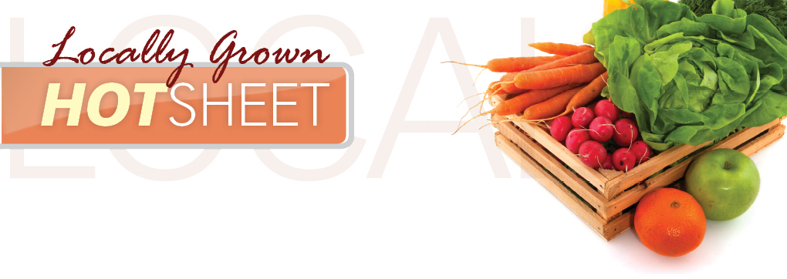
Peaches Glassboro, NJ
Mushrooms Avondale, PA
Yellow Squash Monroeville, NJ
Green Zucchini Monroeville, NJ
Blueberries Hammonton, NJ
Cucumber Monroeville, NJ
Eggplant Swedesboro, NJ
Green Peppers West Deptford, NJ

